41.36: a) Since the given 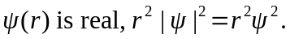 The probability density will be an extreme when
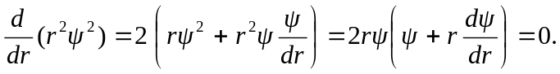
This occurs at 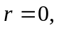a minimum, and when 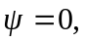also a minimum. A maximum must correspond to 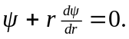Within a multiplicative constant,
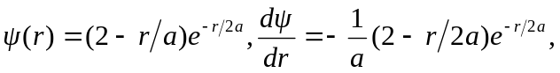
and the condition for a maximum is
The solutions to the quadratic are 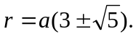 The ratio of the probability densities at these radii is 3.68, with the larger density at 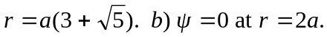 Parts (a) and (b) are consistent with Fig.(41.4); note the two relative maxima, one on each side of the minimum of zero at 